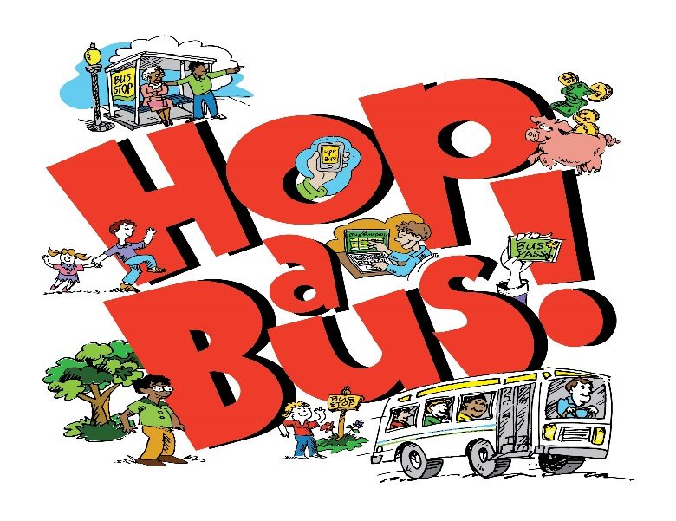

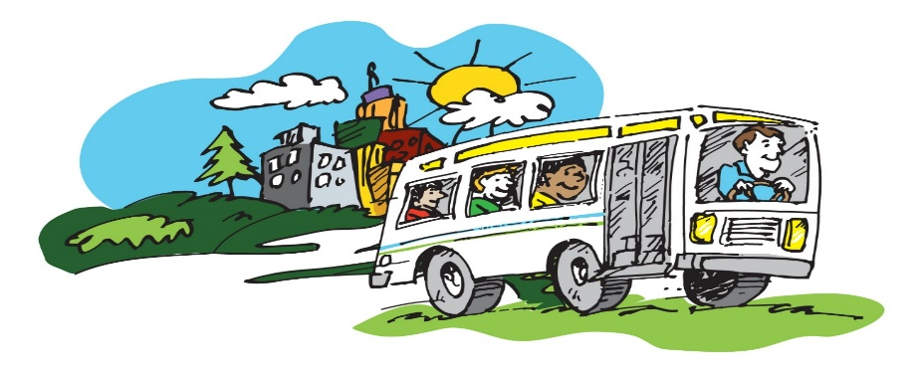

Mountain Transit Authority
1096 Broad Street, Summersville, WV 26651
Phone: (304) 872-5872 Fax: (304) 872-5877

Mountain Transit Authority
1096 Broad Street, Summersville, WV 26651
Phone: (304) 872-5872 Fax: (304) 872-5877

Pocahontas County
Bus Schedule
BARTOW ROUTE
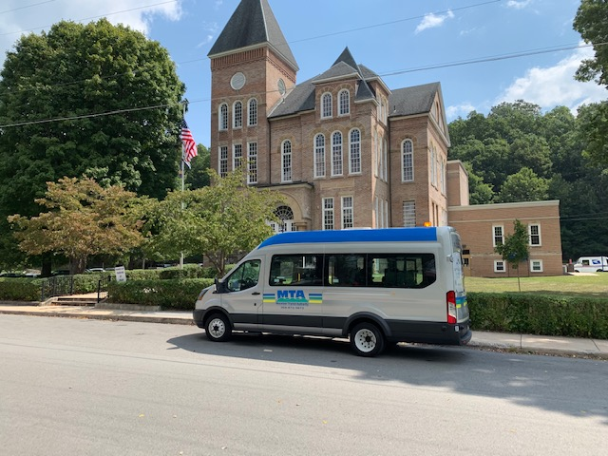
Serving:
Marlinton, Huntersville, Dunmore, Green Bank, Arbovale, and Bartow

WWW.MTAWV.COM

TDD: (304) 872-5872
Toll-Free: 1(877) 712-9432

Monday-Friday
Bartow Route | AM | PM
2nd Ave. Across from City Hall | 5:30 | 3:30
Huntersville- Rt 39/28 Intersection | 5:45 | 3:45
Dunmore Rt 92/28 Intersection | 6:15 | 4:15
Green Bank | 6:30 | 4:30
Arbovale | 6:40 | 4:40
Bartow- Interstate Hardwoods | 6:55 | 4:55
Bartow- Interstate Hardwoods | 7:00 | 5:00
Arbovale | 7:15 | 5:15
Green Bank | 7:25 | 5:25
Dunmore Rt 92/28 Intersection | 7:40 | 5:40
Huntersville- Rt 39/28 Intersection | 8:10 | 6:10
2nd Ave. Across from City Hall | 8:25 | 6:25

SERVICE HOURS AND HOLIDAYS
Our administrative office is located at MTA 1096 Broad Street, Summersville, WV 26651, and office hours are Monday-Friday,
8 a.m. to 4 p.m.

Buses do not operate on the following holidays: •

New Year’s Day - Martin Luther King Day
President’s Day - Memorial Day -July 4th - Labor Day
Columbus Day- Veteran’s Day – Thanksgiving Day
Friday after Thanksgiving - Dec. 24, 25, 26 & 31

FARES | Marlinton | Huntersville | Dumore | Green Bank | Arbovale | Bartow
Marlinton |  | $2.00 | $3.00 | $4.00 | $4.00 | $5.00
Huntersville | $2.00 |  | $2.00 | $3.00 | $3.00 | $4.00
Dunmore | $3.00 | $2.00 |  | $1.00 | $2.00 | $2.00
Green Bank | $4.00 | $3.00 | $1.00 |  | $1.00 | $1.00
Arbovale | $4.00 | $3.00 | $2.00 | $1.00 |  | $1.00
Bartow | $5.00 | $4.00 | $2.00 | $1.00 | $1.00

HOW TO RIDE THE BUS

The bus will not stop unless passengers are visible alongside the main road. When passengers see the bus approaching, wave your hand at the driver to indicate that you wish the bus to stop.
• Not all watches are set to the same time, so be at the bus stop early!
• ANYONE can ride the bus! MTA does not discriminate against an individual on the basis of race, color, creed, religion, national origin, sex, marital status, status with regard to public assistance, disability, age or familial status in the provision of public transportation services.
• For information on our nondiscrimination obligations or to file a complaint, please contact MTA or visit www.mtawv.com
• All buses have wheelchair lift equipment.
• 3/4 mile deviation service is available. Please call at least the day before to schedule your ride. Additional charges may apply. Please call for information.
• Schedules are available in alternative formats upon request.
• Passengers with disabilities may request modification to current service procedures to access the service. To make a request, please call (304) 872-5872 or email admin@mtawv.com. Please submit requests at least the day before the trip.
• For your safety, please be seated quickly after boarding and remain seated until the bus comes to a complete stop.
• Loud music or noise is not permitted on buses. No disorderly conduct is permitted on buses. Anyone not complying will be asked to leave the bus.
• Federal regulations ban smoking and drinking on buses.
• No pets are allowed on buses except service animals.
Suggestions, complaints or compliments? We would like to hear from you. Call toll free, 1-877-712-9432, or write to:
MTA, 1096 Broad Street, Summersville, WV 26651

