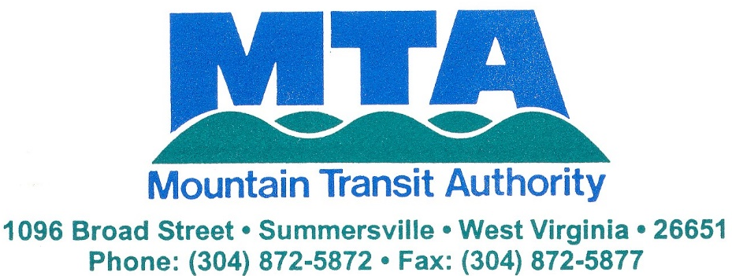

JOB OPENING AVAILABLE

Job Title: Route Bus Driver for Pocahontas County

Reports to: Operations Manager / General Manager

Type: Part-Time to Start- Full-time Possible

The Mountain Transit Authority in Pocahontas County is looking to hire two (2) part-time bus operators immediately. Hours of operation will be between 5:30am-7:30pm, Monday-Friday. Split shift may be required. Full-time status will receive vacation, sick leave and insurance.

Pre-employment drug screening is required. Starting rate of pay is $11.00 per hour. The applicant must have at least a Class C CDL with passenger endorsement. MTA may hire someone with a Class D license and allow 60 days to obtain CDL.

Duties / Responsibilities:

Policies & Procedures:
- Must adhere to the requirements and policies set forth in the MTA Personnel Policy and Procedures Handbook.
- Must adhere to the MTA Maintenance Policy.

Driving:
- Must be insurable
- Must have a clean driving record
- Must pass pre-employment physical
- Must comply with federally mandated drug and alcohol policy and screening requirements
- Must be physically able to operate a bus
- Must observe all traffic laws
- Must drive buses in a safe manner at all times
- Must be able to understand and follow written and oral instructions
- Must possess a mechanical aptitude for simple mechanical diagnosis/repair
- Must be able to read and understand service manuals
- Must be able to complete written reports clearly and accurately
- Must be punctual
- Split Shift work required
- Any other duties/responsibilities as assigned

Please apply by calling MTA at (304) 872-5872 or apply in person at 1096 Broad Street in Summersville, WV.

