Mountain Transit Authority
1096 Broad Street, Summersville, WV 26651
Phone: (304) 872-5872 Fax: (304) 872-5877
OPEN Job Interviews
For Bus Driver
NEW Pocahontas County Service
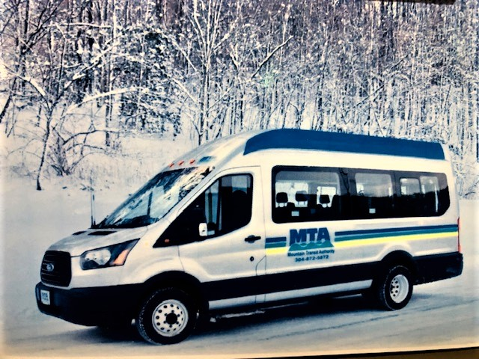
SEPTEMBER 11, 2019
10:00am-1:00pm
Pocahontas County Library
500 8th Street
Marlinton, WV
Senior Citizens and Retirees are encouraged to apply
Call (304) 872-5872 for more details or stop by.

